**AWS RDS**

RDS is a managed service:

* Automated provisioning, OS patching
* Continuous backups and restore to specific timestamp
* Monitoring dashboards
* Read replicas for improved read performance
* Multi AZ setup for DR
* Maintenance windows for upgrades
* Scaling capability
* Storage backed by EBS (gp2 or io1)
* But you can’t SSH into your RDS instances.

RDS – Storage Auto Scaling

* Helps you increase storage on your RDS DB instance dynamically (i.e scales automatically when out of database storage)

RDS – Read Replicas

* Up to 5 Asynchronous Read Replicas Within AZ, Cross AZ or Cross Region
* Replicas can be promoted to their own DB and have it own life cycle
* RDS RR within the same region free, but we have replication fee for Cross Region.

RDS – Multi AZ

* Automatic failover to standby DB in case of any failure.
* No manual intervention on Standby DB (i.e no one can read or write)
* Read Replica can be setup as Multi AZ (standby).
* No downtime or no need to stop RDS DB if you want to move from Single-AZ to Multi-AZ, you can Just click on modify and enable Multi-AZ. Internally a snapshot will be taken and a new DB is restored from if and then sync is done between the 2 DB.

RDS – Custom (only for Oracle and Microsoft SQL)

* This allows us to SSH and give full Admin access to OS and DB.

Amazon Aurora (Not open Sourced) (MySQL, PostgreSQL)

* Aurora storage automatically grows from 10GB to 128TB.
* Aurora can have 15 ReadReplicas and faster replication (10ms replica lag) and instantaneous failover.
* Aurora 20% more Costs than RDS – but is more efficient.
* 6 copies of your primary DB across 3 AZ and self healing with peer-to-peer replication
* Aurora cluster has WRITER ENDPOINT pointing to Master & READER ENDPOINT pointing to ReadReplica, RR has Autoscaling and Load balancing.

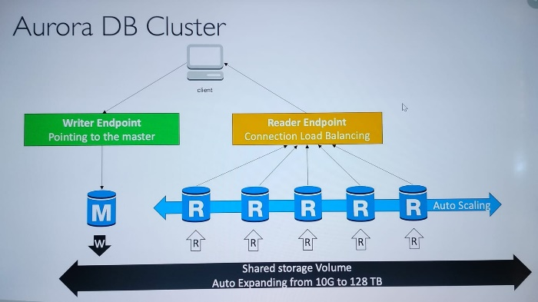

**ElastiCache**

* RDS is to get managed Relational DB & ElastiCache is to get managed Redis or Memcached.
* Caches are in-memory databases with high performance, low latency and reduce load of DB for read workloads.
* AWS takecare of OS patching, optimizations,setup,configuration,monitoring,failure recovery and backup.
* Application queries ElastiCache, if Data not available, gets from RDS and store in ElastiCache.

|  |  |
| --- | --- |
| Redish | Memcached |
| Multi-AZ,ReadReplica,HA,data durability,backup & restore | Multi-node for partitioning of data.  No HA, no data durability,no backup & restore. |

**ElastiCache – Cache Security:**

* All Caches in ElastiCache do not support IAM Authentication.
* IAM policies on ElastiCache are only used for AWS API-level security.

Redis AUTH:

* You can set a “Password/token” when you create a Redis cluster, this is a extra level of security on top of Security Groups.
* Also support SSL in flight encryption.

Memcached:

* Support SASL-based authentication (advanved)

**Patterns for ElastiCache:**

* Lazy Loading: all the read data is cached, data can become stale in cache.
* Write Through: Adds or update data in the cache when written to a DB(no stale data)
* Session store: Store temporary session data in a cache(using TTL features)

**List of Ports to be familiar with**

Here's a list of **standard**ports you should see at least once. You shouldn't remember them (the exam will not test you on that), but **you should be able to differentiate between an Important (HTTPS - port 443) and a database port (PostgreSQL - port 5432)**

**Important ports:**

* FTP: 21
* SSH: 22
* SFTP: 22 (same as SSH)
* HTTP: 80
* HTTPS: 443

**vs RDS Databases ports:**

* PostgreSQL: 5432
* MySQL: 3306
* Oracle RDS: 1521
* MSSQL Server: 1433
* MariaDB: 3306 (same as MySQL)
* Aurora: 5432 (if PostgreSQL compatible) or 3306 (if MySQL compatible)